Discuss:

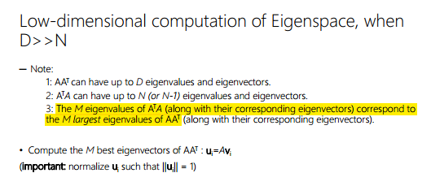

About low-dimensional computation of Eigenspace when D >> N
It is (A.T).A
The advantage of it is the speed, but the disadvantage is that it can only be used to compute eigenvalues, not eigenvector for our PCA problem.
Because : originally A.(A.T) would have eigenvector of size (D,1), that the size we want, but (A.T).A have eigenvector of size (N,1) that not the size we want.

In the computations done by python, some computations are approximation, thus, there is a little minor error from the theoretical value.

